**Useful & Free Digital Tools for Literacy Support in the Classroom Workshop**

**by Miranda Howell & Stephanie Layec.**

Experienced ESOL teachers Miranda Howell, Learning Village, and Stephanie Layec, Howick College, will provide a **hands-on workshop** demonstrating a range of useful, free, digital tools for literacy support and assessment in the classroom.  
**Workshop Outline:**  
There are a myriad of digital apps and resources for the classroom and it's difficult to know where to start. We will share a selection which have proven to be very popular for their ability to engage students through interactive and/or collaborative learning online. They are easy to use and provide instant assessment and feedback to teachers, saving hours of marking. The selected tools have all been used in the classroom by the presenters and can be adapted for all ages of learners. You can also differentiate for different levels. This event is designed to be a workshop and you will need to bring a digital device.

This is an opportunity to **test out** some vital tools to help equip ESOL teachers for the demands of online and teaching, as well as homework. There will be scope to DIY!  
***Thursday 25 March, evening, Unitec, 139 Carrington Road, Mt Albert.***

**Presenter Biographies**

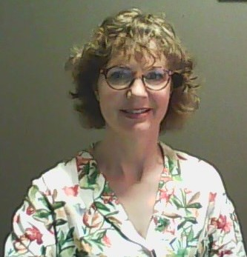

I work for the Learning Village as an EAL specialist, supporting teachers online in both Primary and Secondary schools. I’m a Mindlab graduate in digital and collaborative learning. I have had a broad range of experience having taught English in the UK, the Sultanate of Oman, Malaysia and New Zealand from Primary to Tertiary and community English. Trained as a primary school teacher, I have worked with the Primary Years Programme (IB), International Middle Years Curriculum and secondary Cambridge Curriculum in addition to our New Zealand curriculum. I have been a curriculum leader and developer. My more recent roles include being a teaching and learning coach in schools and an academic leader. My heart is particularly with the challenges that migrant and refugee students face when coming to Aotearoa.

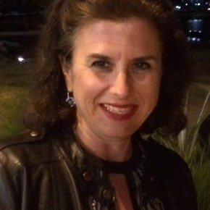

I am HOD of ESOL and Dean of International Students at Howick College, an @MindLab grad, Certified MIE, and Flipgrid Educator.

I have a passion for languages, e-lerning and crafts. I speak French (thanks to my father), English (thanks to my mother) and Spanish (thanks to my hard work). I am relatively new to Aotearoa, having emigrated from France with my husband in 2015. Like Frank Smith, I believe that *"One language sets you in a corridor for life. Two languages open every door along the way."*

Ngā mihi

**STEPHANIE LAYEC**