Welcoming Schools for Students from Refugee Backgrounds: A Trauma Informed Culturally Responsive Approach to Education
Friday 16th September 9.30-3.00pm
Settlement Centre Waikato, Hamilton Multicultural Services Trust,
46G Boundary Road, Claudelands, Hamilton 3214
Programme
Refugees as Survivors NZ is a specialist mental health agency based at the Mangere Refugee Resettlement Centre/ Te Āhuru Mōwai o Aotearoa. We have a regional team of clinicians, youth workers, family support services and cross-cultural facilitators.
RASNZ therapeutic and training teams provide professional development opportunities for professionals across a range of disciplines, including health and mental health, social service education, the refugee resettlement NGO sector and many others. This workshop is designed to support your work with children and young people from refugee backgrounds. This practical workshop aims to support effective practice based on the principles relevant to trauma responsiveness in schools for refugee background students. We will offer information about the services and supports available to students and families in the Hamilton region.
This workshop will explore the following areas of:
- The refugee journey and resettlement in New Zealand
- Working with collective cultures
- How trauma impacts children and young people’s brain, body, memory, emotions, relationships, behaviour and capacity to learn
- Responses to traumatised children and young people within education settings
- Exploration of activities and strategies that can help heal the impacts of trauma to enable improved behavioural and cognitive capacity
- Case scenarios
- Services and supports for schools/agencies
Registration Form - The workshops are free
Name:

Role:

School/Organisation/Service:

Email:

Cell:

e-mail your registration to annette@rasnz.co.nz
You will receive confirmation of your booking
Lunch will be provided
Facilitators Bios

Julia (Ismat) Sheikh: Clinical Team Leader for RASNZ’s Community Clinical Team
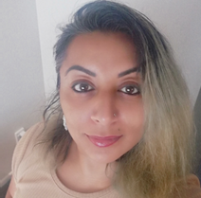
I am a former refugee, and a Muslim woman. I am the Clinical Team Leader for RASNZ’s Community Clinical Team in the Auckland region. Trauma, family separation, loss and culture shock impacts families and can prevent young people and parents successfully moving forward with their lives. We ensure that effective, culturally-sensitive mental health services are provided to newcomers to meet individual needs.
I have extensive experience working with clients and families from refugee backgrounds in the refugee resettlement, mental health, youth counselling, family violence, social service, employment and corrections sectors. I am a fully registered counsellor with expertise in trauma and culturally informed mental health care. I am fully engaged and networked with diverse refugee communities and the refugee resettlement sector in a personal, voluntary and professional capacity.
I have a strong background in crisis intervention, providing clinical support to the Christchurch Mosque attack victims. As well, I have worked with Shakti, the Fatima Foundation, the Salvation Army and NZ Police ethnic liaison officers to ensure a place of safety for women and children from refugee backgrounds in at risk situations. Additionally, I have a personal and professional commitment to early intervention and refugee youth development.
In my role, I lead programmes which include the development of refugee mental health intervention strategies to support recovery and safe integration into New Zealand society. I am also a trainer and educator working with governmental and non-governmental organisations to build organisational cultural competency and capacity to respond to the refugee groups they serve.

Annette Mortensen
Manager: Training and Development based at Te Ahuru Mowai o Aotearoa (Mangere Refugee Resettlement Centre)

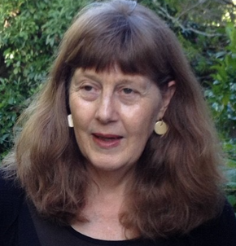
Annette has worked for over 20 years to improve healthcare responsiveness for Asian, refugee and migrant groups in New Zealand in a number of roles including as a public health nurse, project manager, researcher and educator. From 2000, Annette had the position of Refugee Health Coordinator for the Auckland Regional Public Health Service.
In 2007, Annette took up the position of Refugee and Migrant Project Manager for the NRA (Northern Regional Alliance) where she commissioned a number of studies including the Asian and MELAA (Middle Eastern, Latin American and African) Health Needs Assessments of people living in the Auckland region and the Asian Health in Aotearoa trend studies. In the same year, Annette was awarded with the Supreme Harmony Award for her contribution to Muslim relations in New Zealand by the Federation of Islamic Associations of New Zealand (FIANZ).

In 2009, she received a doctorate from Massey University. The subject of her thesis was ‘Refugees as ‘Others’: Social and Cultural Citizenship Rights for Refugees in New Zealand Health Services’. Annette currently works for Refugees as Survivors NZ (RASNZ) as the manager of Training and Development.

