Minutes of **TESOLANZ Executive Meeting: 9 December 2024**

**6.45 – 7.55pm**

**Present:** Gwenna Finikin (President & draft minute taker), Margi Memory (Treasurer), Julie Luxton (Branch Liaison), Juliet Fry (SIG Liaison), Lucy Macnaught (PLD)

**Apologies:** Mark Dawson-Smith, Christine Hanley

1. **Standing Items**
2. **Apologies**
3. **Minutes of the Previous Meeting**
   1. Appendix A
      1. Motion – That the minutes of the meeting held on 15/10/24 be accepted as true and correct. [Margi / Juliet] – **Carried**
4. **Matters Arising**
   1. NZQA English language micro-credentials design and development subject expert panel: Sally Conway, Unitec nominated
   2. Secondary membership survey and letter – Juliet
   3. Follow-up letter from TESOLANZ to Ellen MacGregor-Reid and Derek Lyons – Appendix H
   4. Name change for TESOLANZ – discussion deferred to February 2025 meeting
5. **Executive Reports**
   1. Appendix B: President’s report.
   2. Appendix C: Treasurer’s report
   3. Appendix D: Branch Liaison report
   4. Appendix E: SIG Liaison report
   5. Appendix F: Publications report
      1. Motion to receive the reports [Juliet/Margi] - **Carried**

1. **Agenda Items**
   1. SIG Terms of Reference – Juliet Fry. Worked through this.
      1. **Action:** It will be sent back to Daryl for checking then back to the committee. The Terms of Reference will help the SIGs focus on what they will do for the year.
   2. Showing the Google doc file sharing space and discussing timeframes for uploading files to it - Lucy Macnaught.
      1. Motion that funds of up to $300 for paying Jay to sort out Microsoft accounts, add an account, and provide documented details about process for future reference be made available [Lucy/Margi].
      2. **Action:** Gwenna to contact Marty about liaising with Jay about this.
   3. SIG leader succession: Juliet will be standing down at the next election. An opening will be available in the SIG liaison area.
   4. TESOLANZ Executive 2025 meeting dates:

Monday 10 February   
Monday 7 April   
Monday 9 June   
Monday 11 August   
Monday 13 October   
Monday 8 December

* 1. 2025 AGM event – Via Zoom or Teams. Each branch to have a face-to-face meeting on the day then join online for the AGM.
     1. **Action:** Gwenna to have a training meeting with the branch leaders beforehand to make sure they know to send details of voting reps before the AGM, and that any remits need to be discussed by branch members.
  2. Reminder for next meeting that we all need to research name changes.

1. **Any other business**
   1. Approach received from Karen Ashton, Massey University, about a professional opportunity.
      1. **Action**: Julie and Juliet to have a preliminary discussion about possibilities.

**Meeting closed 7:55 pm**

**Next meeting: February 10 2025**

**Appendix B**

**President’s report**6.11 Meeting with the branch leaders

12.11 Sent endorsement of Sally Conway to Nigel Evans

17.11 TESOL International meet and greet (2 am)

6.12 Termly meeting with ministry - Maree Jeurissen and colleagues

Gwenna Finikin

**Appendix C**

**Treasurer’s report**

The Balance Sheet and Profit and Loss as at December 6th, 2024 also submitted.

**BRANCH CAPITATIONS**

Branch capitation to be completed this month for those branches that have submitted documents.

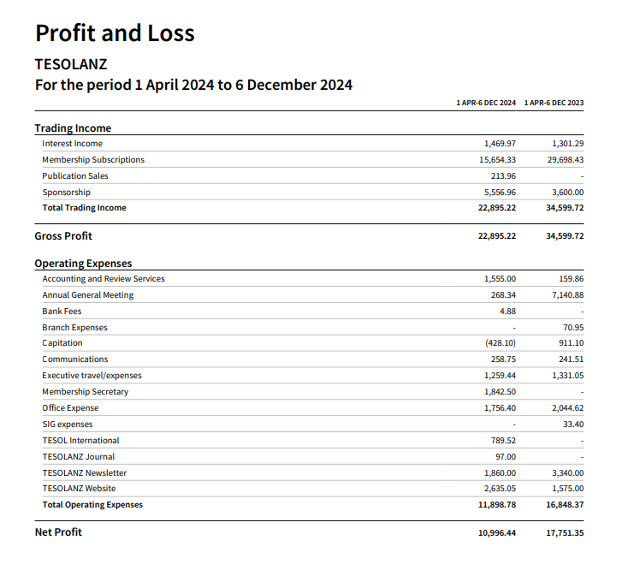

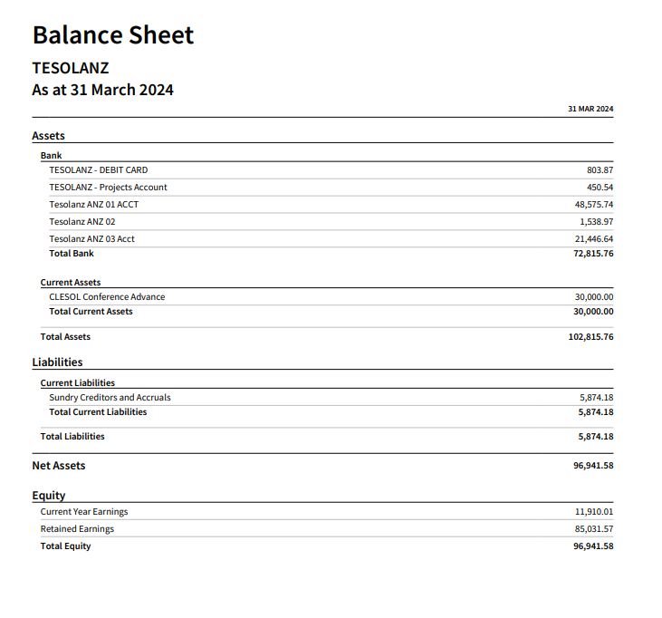Margi Memory

**Appendix D**

**Branch Liaison Report**

A range of events has been organised by branches since the AGM Branch Liaison Report. These include presentations on integrating conversational AI into language teaching with Antonie Alm, Associate Professor in Languages & Cultures at the University of Otago (OtagoTESOL), NCEA literacy requirements and English language learners with Breda Matthews and Julie Luxton (AKTESOL), supporting L2 learners’ writing development (WATESOL), how do language teachers understand language (Waikato TESOL), and a roundtable discussion (ManaTESOL). These events have all been advertised on the What’s On calendar and most have been available online for TESOLANZ members.

BOPTESOL bank account issues have been resolved and new signatories assigned.

A meeting of Branch Chairs was held on 6 November 2024. Gwenna went through the updated Branch Handbook and addressed related questions and concerns. Thank you to Gwenna for her ongoing support of TESOLANZ branches.

Julie Luxton

**Appendix E**

**SIG report**

1. Tertiary SIG coordinator (Daryl Street) sorted and steering group established (Christine Hanley, Mark D-S, Amber Fraser-Smith (Otago Polytech) Christine Biebricher (AU) Tim Edwards (VUW) - no meeting yet as times difficult to sync - plan to get a rep from PTEs on the steering group
2. ECE SIG a job for 2025 - Juliet to contact ECE associations
3. On Daryl’s advice, Terms of Reference drafted - see attachment and discuss
4. Letter sent on behalf of secondary SIG by Gwenna to MOE re curriculum development being inclusive of EAL - no reply yet - we need to put these on TESOLANZ website, once a reply is received
5. Successful Sec SIG meeting - a social gathering online
6. Sec steering group members piloted a draft survey about ELLs and the Literacy CAAs. Further discussion about the purpose of the survey and related refinements deferred to early next year
7. Special thanks to SIG coordinators Sally Hay, Karen Cebalo, Sarah Roper

Juliet Fry

**Appendix F**

**Publications report**

* Christine has continued to do a cracking job in her role of Newsletter Editor, with the last edition of 2024 published at the start of November. It was another bumper edition, 29 pages in total, and packed full of articles of interest. In addition, the Newsletter also included one full-page advert and four half-page adverts, all of which help with the cost of publishing the Newsletter three times a year.
* The next edition of the TEOSLANZ Journal (Vol. 32) has been pushed back a bit, as Olly had not received many articles. It was agreed to extend the deadline for articles until December 20th, and we are hoping that this will provide us with more articles so that the Journal can be published early in 2025. Note that this is a huge extension on the original closing date for submissions, which was August 1st, 2024, but it is needed if we are to publish a quality edition of the TESOLANZ Journal. Thanks go out to Olly, as always, for his leadership in the massive job involved with publishing a journal.

Mark Dawson-Smith

**Appendix G**

**TESOLANZ SIG Terms of Reference 2024**

Type of Group: Special Interest Group (SIG) Steering Groups

ECE Primary Secondary Tertiary

### Purpose

Provide a platform and sounding board to support the SIG coordinator(s) to meet the constitutional purposes of TESOLANZ:

* to promote the professional interests and cater for the needs of teachers of English to learners from language backgrounds other than English;
* to promote the interests and cater for the needs of learners from language backgrounds other than English;
* to cooperate with community language action groups in identifying and pursuing common goals;
* to publish research, materials and other documents appropriate to the Association’s aims; and
* to affirm the maintenance of Te Reo Māori under the Treaty of Waitangi.

### Term

The committee will exist for the duration of the a year and be reaffirmed/ reconfigured at the time of the next TESOLANZ AGM by the TESOLANZ executive SIG coordinator

### Scope

Provide a platform to support the SIG coordinator(s) to achieve the purposes above and to act as connecting points for various organisations such as those outlined below:

* **Tertiary:** ALANZ, ALTAANZ, English New Zealand, TESOL International, IATEFL
* **Secondary:** PPTA, MOE Professional Learning Clusters, MOE regional subject association groups
* **Primary:** NZEI, MOE Professional Learning Clusters
* **ECE:** NZECEA, Early Childhood Council

### Representation

Sector steering groups generally support the following groups but include some cross-overs.

* **Tertiary sector represents:** universities, polytechnics, Private Training Establishments, Adult & Migrant education.
* **Secondary sector represents:** Years 8-13secondary schools & area schools, including state, integrated and private schools
* **Primary sector:** Years 1-8 primary schools & area schools, including state, integrated and private schools
* **ECE:** Ages0-6kindergarten, pre-school, playcentres

### Authority

The committee will draft communications but direct communication with any government organisation (e.g. MOE, NZQA) will happen via the TESOLANZ executive and ultimately through the TESOLANZ president.

### Membership

The committee will consist of a SIG coordinator or co-coordinators agreed to by the TESOLANZ executive SIG coordinator and up to six other TESOLANZ representatives from the sector. TESOLANZ executive members (SIG steering Group Members or TESOLANZ executive SIG coordinator or President) will be invited to meetings.

### Meetings

All meetings will be chaired by the SIG coordinator(s). Decisions and communication will require consensus. Meetings will be via zoom as required. Minutes will be recorded and shared with the TESOLANZ executive SIG coordinator. A report on the sub-committee activities will be given at TESOLANZ Exec meetings and each SIG will provide a report for the newsletters.

**Appendix H**

Kia ora Gwenna,

Thank you for getting in touch about English Language Learners in secondary schools.

As you are aware, the refreshed New Zealand Curriculum is being developed and implemented in phases to ensure it is manageable by the sector, with the intention that schools will be using the fully refreshed NZC from the beginning of 2027.

We are in the pre-design phase for the refresh of the learning languages learning area and will be scoping this learning area in 2025. Content for inclusion in this learning area will be considered as part of this process, so I am unable to comment further at this time. It is expected that the learning languages learning area will be released for consultation in late 2025 ahead of planned implementation from the beginning of 2027.

Regarding the development of curriculum-aligned Achievement Standards, these can only be developed for approved NCEA subjects. As mentioned in the [2021 Technical Report - Final NCEA Level 2 and 3 Subject List for the NZC; and approach to Technical Report for NCEA Levels 1-3 Subject for TMoA](https://ncea-live-3-storagestack-53q-assetstorages3bucket-2o21xte0r81u.s3.amazonaws.com/s3fs-public/2022-05/2-v2.-signed-BN-NCEA-L2-3-Subject-List-for-NZC-and-approach-to-Tech-Report-f.._%20%281%29.pdf?VersionId=99a0bV69rH4HES.c6zSRC06bvphW7xBP) English as a Second Language currently sits outside of the scope of the Review of Achievement Standards within the NCEA Change Programme.

Thank you again for your letter and commitment to quality, equitable language education. Wishing you well for the remainder of 2024 and a happy New Year.

Ngā mihi,

Derek

Derek Lyons | Programme Director Te Poutāhū  
Te Poutāhū (Curriculum Centre)

[education.govt.nz](http://www.education.govt.nz/)  
  
*He mea tārai e mātou te mātauranga kia rangatira ai, kia mana taurite ai ōna huanga*  
*We shape an education system that delivers equitable and excellent outcomes*[](https://www.education.govt.nz/)